

**UGANDA NATIONAL EXAMINATIONS BOARD**

**PRIMARY SEVEN MOCK EXAMINATIONS (ANWAR)** **2024**

**INTEGRATED SCIENCE**

**Time allowed: 2 hours 15minutes**

**Index No.**

|  |  |  |  |  |  |  |  |  |
| --- | --- | --- | --- | --- | --- | --- | --- | --- |
| **Random No.** | | | | | | **Personal No.** | | |
|  |  |  |  |  |  |  |  |  |

**Candidates Name:** ………………………………………………………………………………..………………….

**Candidates’ Signature:** …………………………………………………………………………………………….

**School Random No:** …………………………………………………………………………………………..…….

**District ID:** …………………………………………………………………………….………………………………..

**Read the following instructions carefully:**

1. Do not write your **school** or **district name** anywhere on this paper.

|  |  |  |
| --- | --- | --- |
| **FOR EXAMINERS’**  **USE ONLY** | | |
| **QN. NO.** | **MARKS** | **EXR’S NO** |
| 1 - 5 |  |  |
| 6 - 10 |  |  |
| 11 - 15 |  |  |
| 16 – 20 |  |  |
| 21 – 22 |  |  |
| 23 – 24 |  |  |
| 25 – 26 |  |  |
| 27 – 28 |  |  |
| 29 – 30 |  |  |
| 31 – 32 |  |  |
| **TOTAL** |  |  |

2. This paper has two sections **A** and B. Section **A** has

**40 questions** and **section B** has **15 questions**. This paper has **12 pages** printed altogether.

3. Answer **all** questions. All the working for both sections

**A** and **B** must be shown in the spaces provided.

4. **All** working must be done using a **blue** or **black** ball point pen or ink. Any work done in pencil other than graphs and diagrams will  **NOT** be marked.

5. **No calculators** are allowed in the examination room.

6. Unnecessary **changes** in your work and handwriting that cannot be easily ready may lead to loss of marks.

7. Do not fill anything in the box indicated: **“For examiners’ use only**” and the boxes inside the

question paper.

©2024 Uganda National Examinations Board **Turn Over**

**SECTION A (40 marks)**

*(For questions 1-40, carry one mark each)*

1. Write AIDS in full. ………………………………………………………………………………………………………………………………………………
2. Give one disadvantage of friction in machines. ………………………………………………………………………………………………………………………………………………
3. Why is the changing of water into ice referred to as a physical change? ………………………………………………………………………………………………………………………………………………
4. 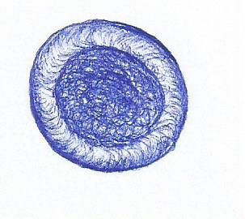State the importance of the blood cell whose shape is drawn below.

………………………………………………………………………………………………………………………………………………

1. Mention one material you would need to prepare Oral Rehydration Solution. ………………………………………………………………………………………………………………………………………………
2. Give one reason why farmers mulch their gardens. ………………………………………………………………………………………………………………………………………………
3. State any one way farmers in Uganda control external cattle parasites. ………………………………………………………………………………………………………………………………………………
4. How is the habit of bees visiting flowers important to plants?

………………………………………………………………………………………………………………………………………………

How does refrigeration prevent food stuffs from going bad? ………………………………………………………………………………………………………………………………………………

1. Why does a fish die when removed from water? ………………………………………………………………………………………………………………………………………………

*Use the diagram below to answer questions 11 and 12.*

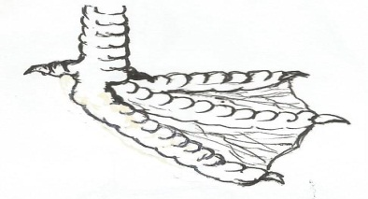

m

………………………………………………………………………………………………………………………………………………

1. Identify the type of birds with such a type of foot. ………………………………………………………………………………………………………………………………………………
2. How do birds with such type of foot make use of the structure labelled M? ………………………………………………………………………………………………………………………………………………
3. State any one law that governs the taking of alcohol in Uganda. ………………………………………………………………………………………………………………………………………………
4. Mention one animal that uses echoes in its movement. ………………………………………………………………………………………………………………………………………………
5. What is the role of sunlight during photosynthesis? ………………………………………………………………………………………………………………………………………………
6. State one reason why you would prefer artificial insemination to natural insemination in cattle keeping?

……………………………………………………………………………………………………………………………………………

1. Identify one health habit that may result into destruction of the human lungs. ………………………………………………………………………………………………………………………………………………
2. Give any one example of a non-renewable resource in the environment.

………………………………………………………………………………………………………………………………………………

1. *What do we call the method of obtaining clean water from muddy water illustrated below?*

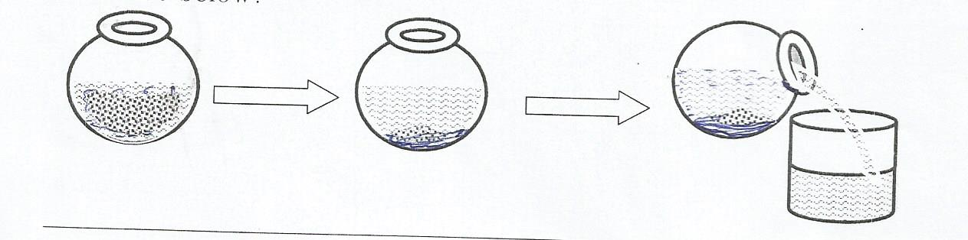

………………………………………………………………………………………………………………………………………………

1. Give one reason why the clean water obtained by the method in No. 19 above is not safe for drinking. ………………………………………………………………………………………………………………………………………………
2. Mention one health problem that may result from over excitement or prolonged hunger.

………………………………………………………………………………………………………………………………………………

1. What is the use of a vent pipe found on a VIP latrine?

……………………………………………………………………………………………………………………………………………

1. Identify any one sex offence faced by adolescents. ………………………………………………………………………………………………………………………………………………
2. In one way, give advice to Mrs. Kafeero so as to control the vice of egg eating on her poultry farm.

………………………………………………………………………………………………………………………………………………

1. Identify one danger that may result from sharing a house with potted plants at night.

………………………………………………………………………………………………………………………………………………

1. State one factor that adapts a housefly to spreading germs.

………………………………………………………………………………………………………………………………………………

1. What form of energy would you employ to make water evaporate? ………………………………………………………………………………………………………………………………………………
2. In one way, state how you would help your young sister to promote personal hygiene.

………………………………………………………………………………………………………………………………………………

1. State the reason why a cockroach moves with its abdomen raised on a floor with maize flour.

………………………………………………………………………………………………………………………………………………

1. Why are electricity wires fixed loosely on poles? ………………………………………………………………………………………………………………………………………………
2. Besides using a child health card, how else can you identify a child who was immunised against tuberculosis?

………………………………………………………………………………………………………………………………………………

1. Names one pest that attacks root crops. ………………………………………………………………………………………………………………………………………………
2. State a health problem children may face if underfed with food rich in carbohydrates. ………………………………………………………………………………………………………………………………………………
3. Calculate the density of an object whose mass is 100g and volume 200cc.

*Use the diagram below to answer the questions 35 and 36.*

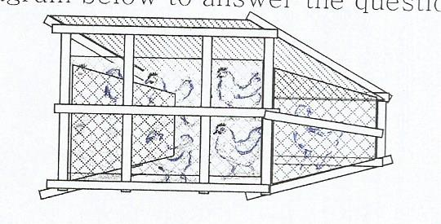

1. Identify the system of poultry keeping illustrated above. …………………………………………………………………………………………………………………………………………
2. Give one advantage of the poultry keeping system illustrated above.

………………………………………………………………………………………………………………………………………………

1. Explain one way how blood is prevented from flowing back along vessels during circulation in the human body. ……………………………………………………………………………………………………………………………………………
2. Besides banana fibres, give one example of a plant fibre.

…………………………………………………………………………………………………………………………………………………………

1. Name the amphibian that lays the eggs drawn below.

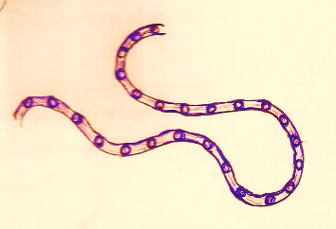

………………………………………………………………………………………………………………………………………………

1. Suggest one way of preventing ourselves from tape worm infections.

………………………………………………………………………………………………………………………………………………

SECTION B (60 marks)

*(For questions 41 – 55 carry four marks each)*

1. a) What is soil erosion? ………………………………………………………………………………………………………………………………………………

b) Write down one agent of soil erosion. ………………………………………………………………………………………………………………………………………………

c) Identify any two dangers of soil erosion. ………………………………………………………………………………………………………………………………………………

a) Name the type of metamorphosis a housefly undergoes. ………………………………………………………………………………………………………………………………………………

b) How is a housefly useful during its larva stage? ………………………………………………………………………………………………………………………………………………

c) Identify any one disease spread by houseflies. ………………………………………………………………………………………………………………………………………………

d) Suggest any one way of reducing the spread of diseases by houseflies. ………………………………………………………………………………………………………………………………………………

*The diagram below a process in nature. Use it to answer the given questions.*

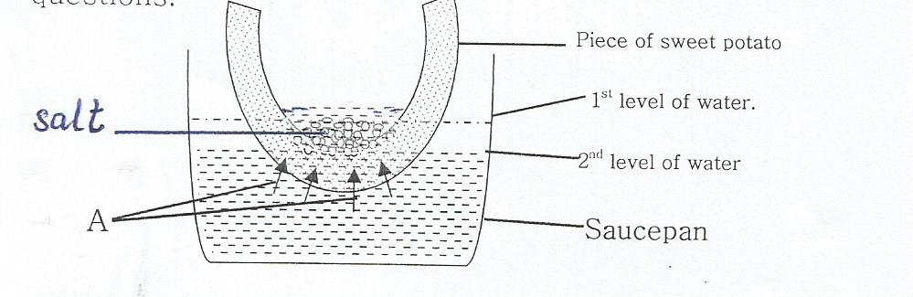

a) Which process in nature is represented above? ………………………………………………………………………………………………………………………………………………

b) What do arrows marked A represent? ………………………………………………………………………………………………………………………………………………

c) .Why did the water level in the saucepan reduce after sometime? ………………………………………………………………………………………………………………………………………………

d) How is the above process useful to plants? ………………………………………………………………………………………………………………………………………………

1. State one activity a family may do to promote;
2. Family sanitation: ……………………..…………………………………………
3. Immunisation: ………………………………………………………………..
4. Food and Nutrition:

…………………………………………………………………

1. Control of communicable diseases

…………………………………………………………….

1. *The diagram below is of a cross- section of an egg. Use it to answer the given questions.*

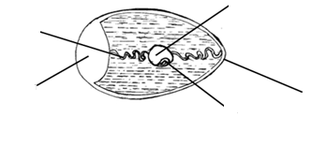

B

D

E

C

A

1. Name the parts labelled C and A

…………………………………………………………………………………………………………………………………….

1. Apart from protecting the inner parts, give one other function of part D. ………………………………………………………………………………………………………………………………………..

c) Which letter indicates the part that develops into a chick? ………………………………………………………………………………………………………………………………………………

a) What is environmental degradation?

……………………………………………………………………………………………………………………………………………………..

1. Outline any two human activities that lead to environmental degradation.

…………………………….………………………………………

…………………………………………………………………..

1. Identify one way by which man helps to allow continued existence of trees. ………………………………………………………………………………………………………………………………………….
2. *The diagram below is of a human organ. Use it to answer the given questions.*

Ossicles

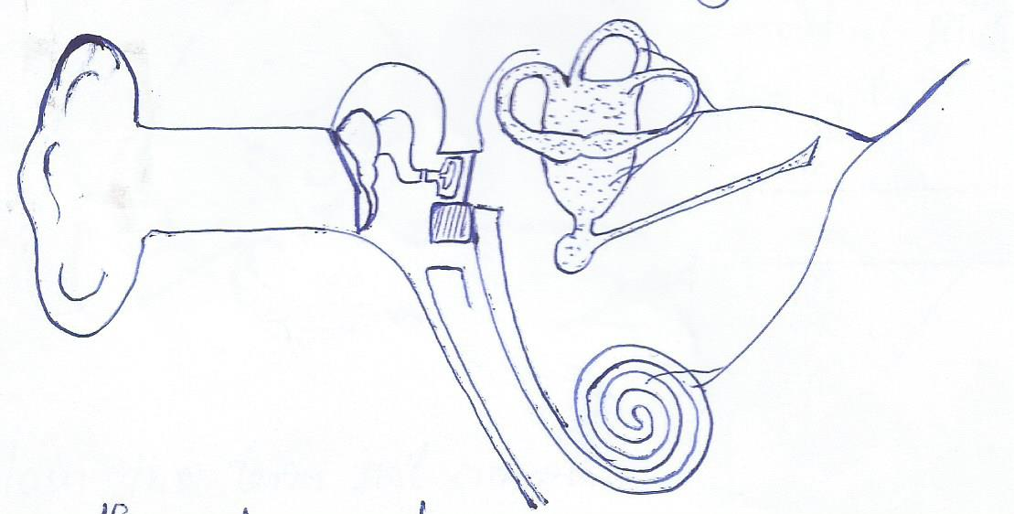

M

O

N

a) Name the part labelled M. ………………………………………………………………………..

b) Give the role of the parts marked O during the hearing process. ……………………………………………………………………

1. Which letter represents the part that equalises the pressure in the ear to the atmospheric pressure?

................................................................................................

......................................................................................................

1. State one major function of the organ in the diagram.

……………………………………………………………………………..………………………………………………………

1. a) Mention any two advantages of a VIP latrine? ………………………………………………………………………………………….…………………………………………………..

b) Suggest any one way of preventing convectional pit latrines from smelling badly. ……………………………………………………………………………………………….………………………………………………

1. Give the reason why a pit latrine should be located at least 30m away from a water source. ……………………………………………………………………..
2. a) In one sentence, describe the first aid you would give a victim of;
3. a burn: ………………………………………………………………………………………………………………………………………………
4. fever: …………………………………………………………………………………………………………………………………………….
5. near drowning: …………………………………………………………………………………………………………………………………
6. Why should a person who has taken paraffin or jik not be made to vomit? ………………………………………………………………………………………………………………………………………
7. *Use the diagram of the thermos flask below to answer the given questions.*

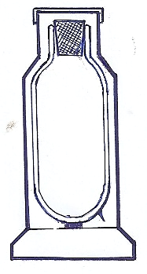 D

E

s

F

1. Name the part marked D

……………………………………………………………………

1. Give the functions of the parts marked F and S. ……………………………………………………………………………………………………………………………………….
2. Explain how the parts marked E control heat loss or gain when the equipment is being used. …………………………………………………………………………………………………………………………………………
3. a) Identify any two problems faced by girls who become pregnant at a tender age. ………………………………………………………………………………………………………………………………………………

b) Identify any two categories of people in our society who stand high risks of catching HIV. ………………………………………………………………………………………………………………………………………

1. *The diagram below shows a method of producing alcohol. Use if to answer the given questions.*

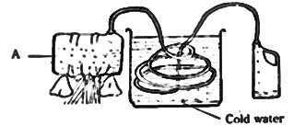

a) Name the method of producing alcohol in the diagram. …………………………………………………………………….

b) State the role of cold water in the process above. ………………………………………………………………………………………………………………………………………………..

c) Mention the form of physical change that takes place in drum A. ………………………………………………………………………………………………………………………………………………

1. Give one use of the alcohol produced by the above method. ……………………………………………………………………………………………………………………………………….
2. a) State two factors you would use to identify a dicotyledonous plant. ……………………………………………………………………………………………………………………………………………

b) Give the role of each factor below during seed germination.

i) Moisture:

……………………………………………………………………………………………………………………………………………..

ii) Oxygen:

……………………………………………………………………………

1. *Match the processes to the gases they need to take place.*

Process Gas

1. Preservation of bottled drinks: carbon dioxide
2. Rusting nitrogen
3. Storage of semen carbon dioxide
4. Putting out fire oxygen
5. Preservation of bottled drinks:………………………………………………
6. Rusting: …………………………………………………….
7. Storage of semen:………………………………………….
8. Putting out fire: ……………………………………….
9. *Use the reproductive system below to answer the given questions.*

U

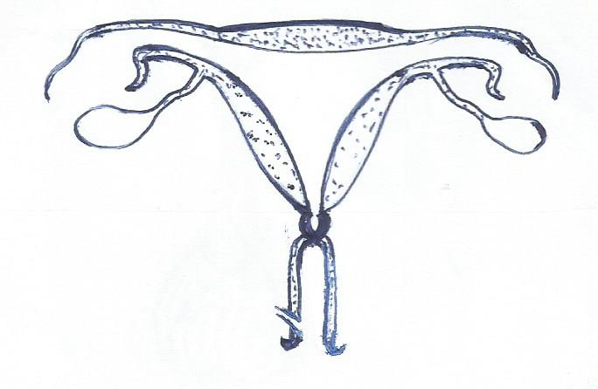

Q

P

T R

S

1. Name the part marked P. ……………………………………………………………………………………………………………………………………………
2. What do we call the type of pregnancy where a zygote implants itself in part Q? ………………………………………………………………………………………………………………………………………………
3. What health problem affects part R that women should always check for? ………………………………………………………………….
4. Which letter indicates the part where sperms are deposited during sexual intercourse?

........................................................................................................................................................................................................................

END